Project Identification

Project: | ShareShake Rental Web App
Prepared By: | Haitham AhmedKhalil, Faheem Choudhury, Kyung-Neung Lee
Document Version: | v 0.1
Published Date: | September 29, 2017

Contributors
The following individuals contributed to this document.
Name | Title
Haitham AhmedKhalil | Developer
Faheem Choudhury | Developer
Kyung-Neung Lee | Developer

Distribution
This document is distributed to all the following people.
Name | Title
Anjana Shah

Referenced Documents
This document refers to the following materials
Version number | Title | Author | Date | Source / Location

Revision History

Version Number | Revision Date | Summary of Changes | Modified by
[Note: It is recommended that drafts be numbered 0.1 to 0.9, and that the first approved version be numbered 1.0. Thereafter, new version numbers will depend upon changes: 1.01, 1.1, etc for minor updates, 2.0, 3.0 etc for major changes.]

TABLE OF CONTENTS
1. Business Context Diagram 3
2. REquirements Scope Statements 4
3. High Level Business Requirements (HLR) Traceability 4
4. High Level Business Requirements Sign-Off 5

- Business Context Diagram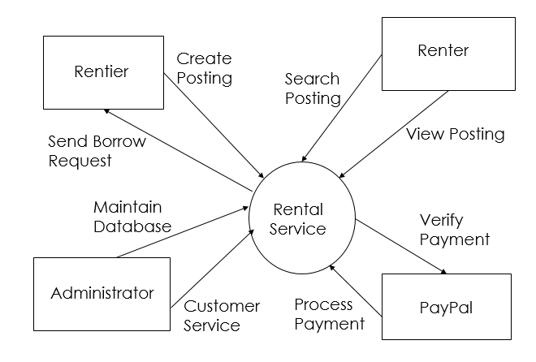

Requirement Scope Area | Description
Rental Service | Application responsible for providing the platform to rent and borrow products

External Entity | Description
PayPal | External application that processes payments
Renter | User who uses the application to borrow items
Rentier | User who uses the application to rent items
Administrator | Administrator that maintains and manages the application

Information Flows | Description
View Posting | View specific details about the item posting
Search Posting | Searches database for items the user is looking for
Create Posting | User creates a listing for the item they are lending out
Send Borrow Request | A renter sends a request to rent out the rentier’s item
Maintain Database | Administrator can manage postings and user information
Customer Service | Administrator responds to any disputes and can answer any queries
Verify Payment | PayPal checks the payment amount and verifies the method
Process Payment | The payment was verified and processed and the user is notified
- Requirements Scope Statements
HLR# | Description | Priority  (H, M, L)
 | Users must be able to make payments for items using PayPal | H
 | Administrators must be able to manage and access user’s account information | M
 | Owners must be able to see traffic information relating to the web application to help business decisions | L
HLR04 | Users must be able to create accounts to use the web application to be able to lend or borrow items | H

- High Level Business Requirements Sign-Off
The undersigned acknowledge their agreement with the contents of Version <x.x> of the High-Level Requirements document for <Project Name>.

Following approval of this document, requirements changes will be governed by the project’s change management process, including impact analysis and appropriate reviews and approvals, under the general control of the Project Plan and according to company policy. Approved Change Request Documents, if present, will be attached to this Requirements Document as updates.

Name | Project Role and  Functional Area | Date Signed

* Note: physical signatures are not required. Email approvals are acceptable and should be appended to project documents.

